Crime Statistics Report
Crime Statistics Report 1
Offenses over the years 1
Which offenses are the most frequent ones? 2
Serious offenses over the years 2
Why are the total numbers in year 2015 and 2018 so low? 3
In which urban areas (district), broken down by year, were most crimes committed? 3
In which urban areas (district) are most serious crimes ('Part One') committed? 3
Which types of serious crimes ('Part One') occur most frequently in the urban area 'B2'? 5
Are there (a) times, (b) days or (c) months when more serious crimes ('Part One') occur? 6
Do crimes tend to occur at night or during the day? 8
When are the most police officers needed? 8
How has the number of shootings developed in recent years? 9
In which district do most shootings take place? 11
In which street do most shootings take place? 12
At what times do most shootings take place? 12

Offenses over the years
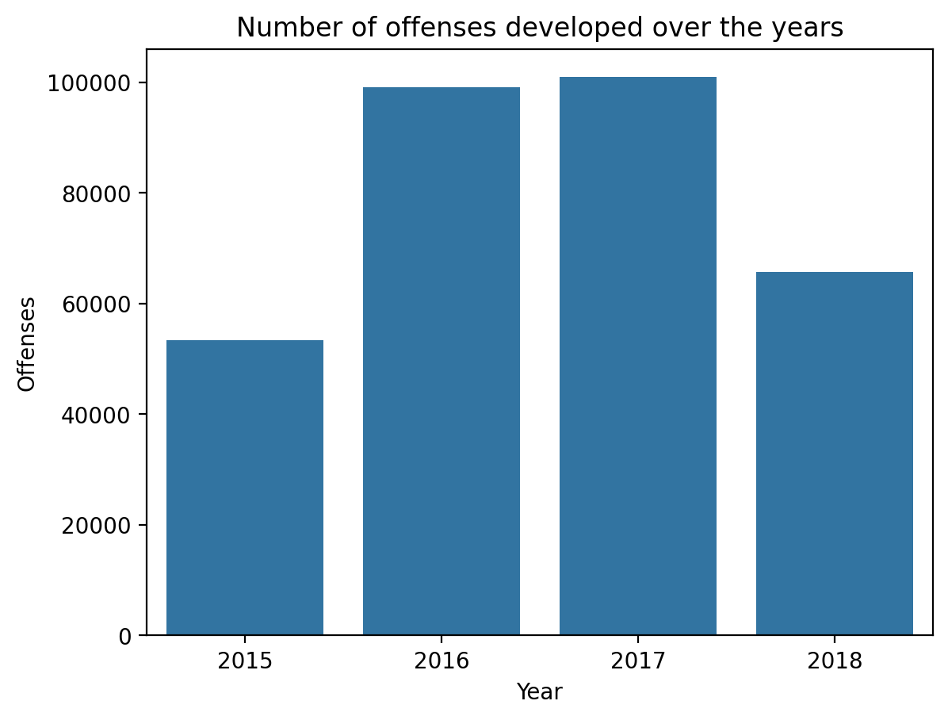

Which offenses are the most frequent ones?
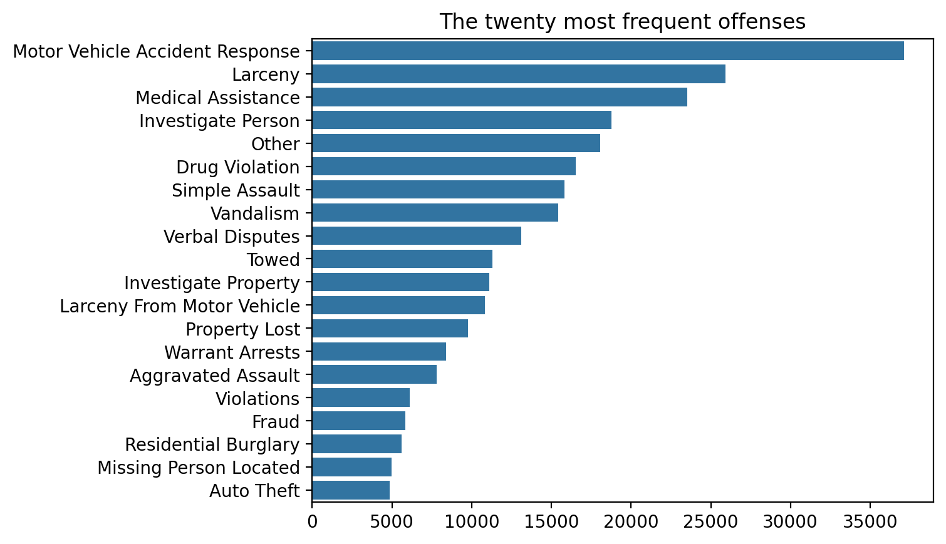

Serious offenses over the years
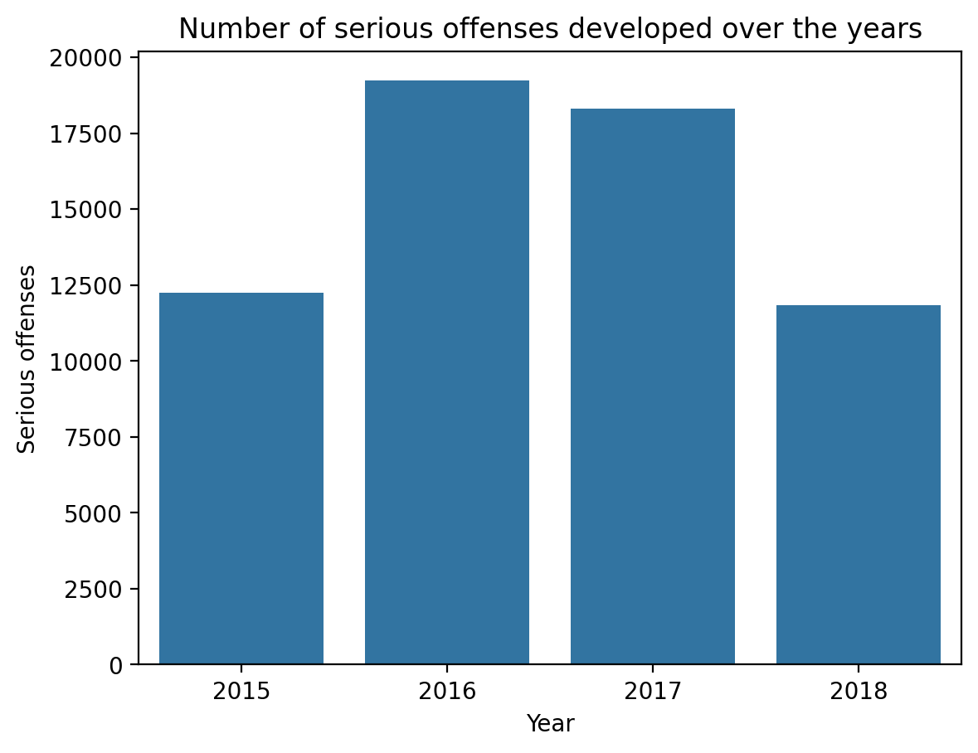

Why are the total numbers in year 2015 and 2018 so low?
Because tracking started not until June in 2015 and ended in September 2018. In these yaers we have not data of twelve months.
- First offense tracked: 2015-06-15 00:00:00
- Last offense tracked: 2018-09-03 21:25:00

In which urban areas (district), broken down by year, were most crimes committed?
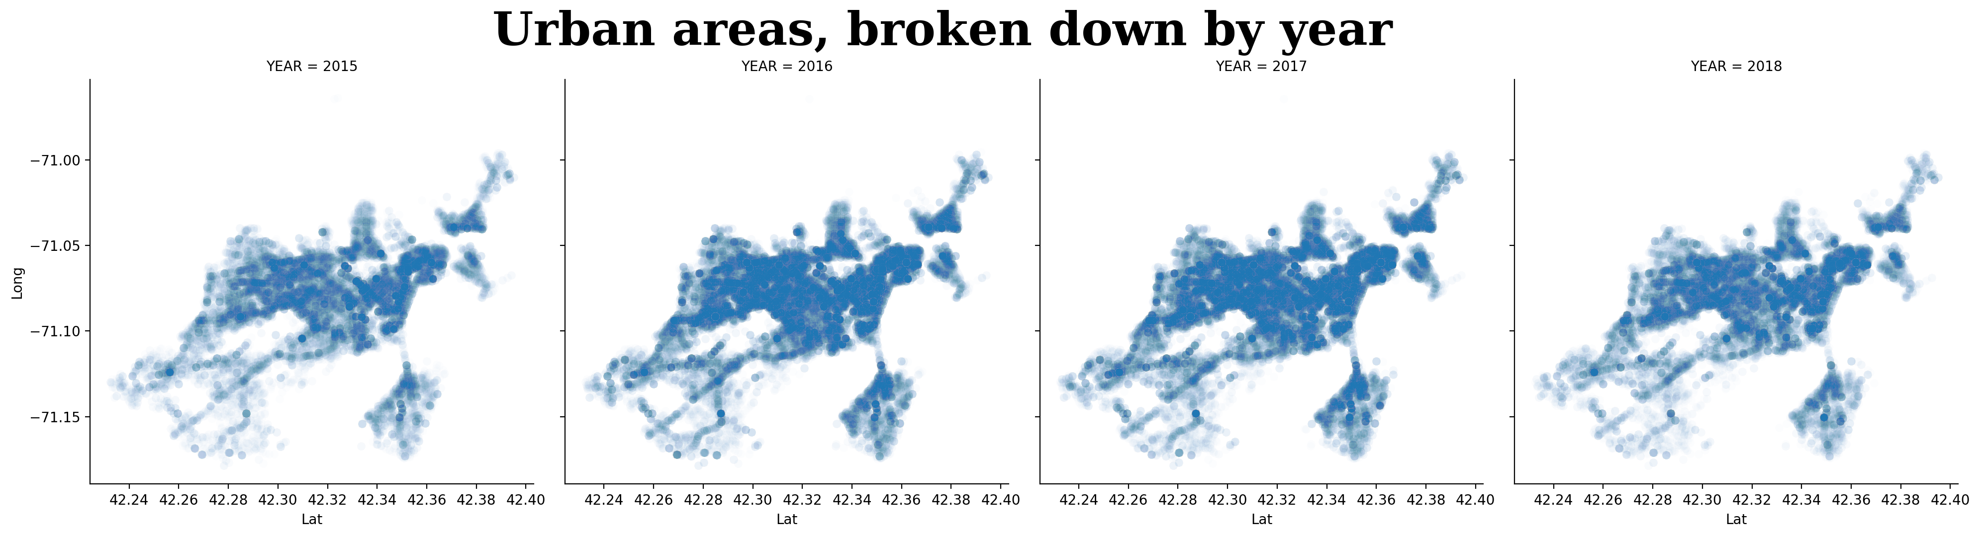
We can see that most offenses happen in the central and eastern districts. Lesser in the western.
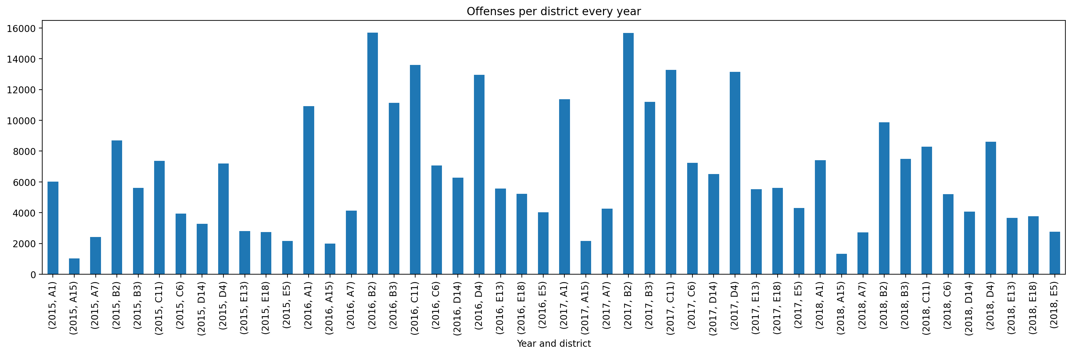
A1, B2, C11 and D4 are crime heavy disricts.

In which urban areas (district) are most serious crimes ('Part One') committed?
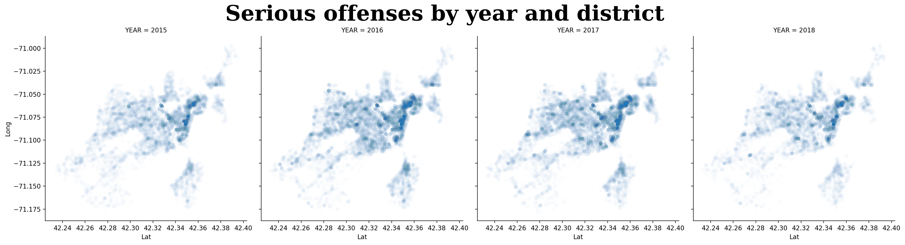
Most serious offenses happen in the eastern disricts.
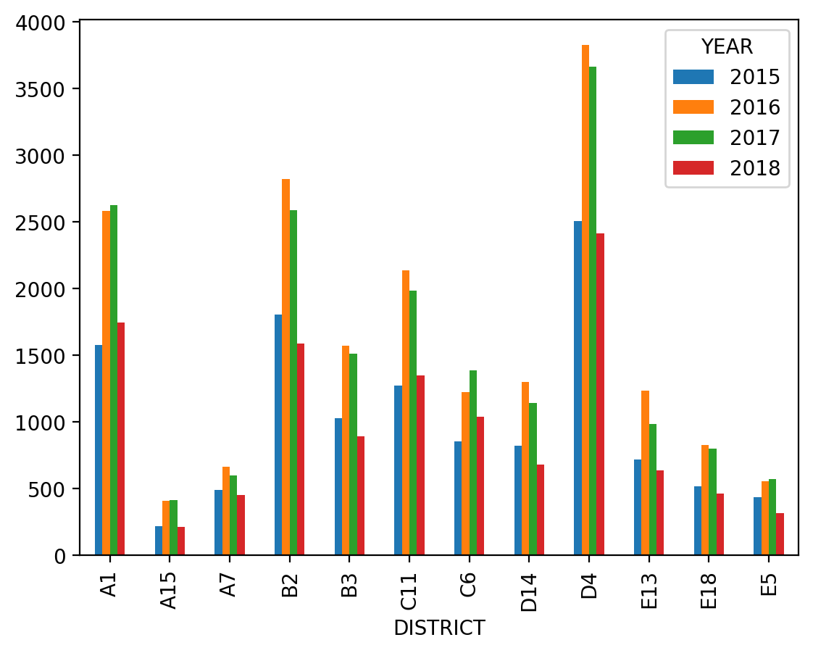
The hotspots are the same districts where the most offenses happen.

Which types of serious crimes ('Part One') occur most frequently in the urban area 'B2'?
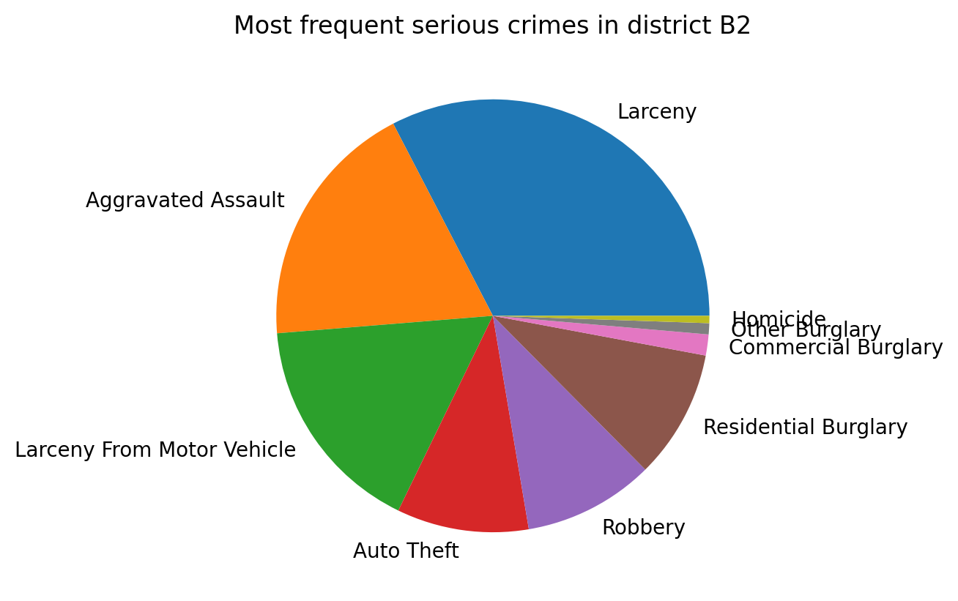

Are there (a) times, (b) days or (c) months when more serious crimes ('Part One') occur?
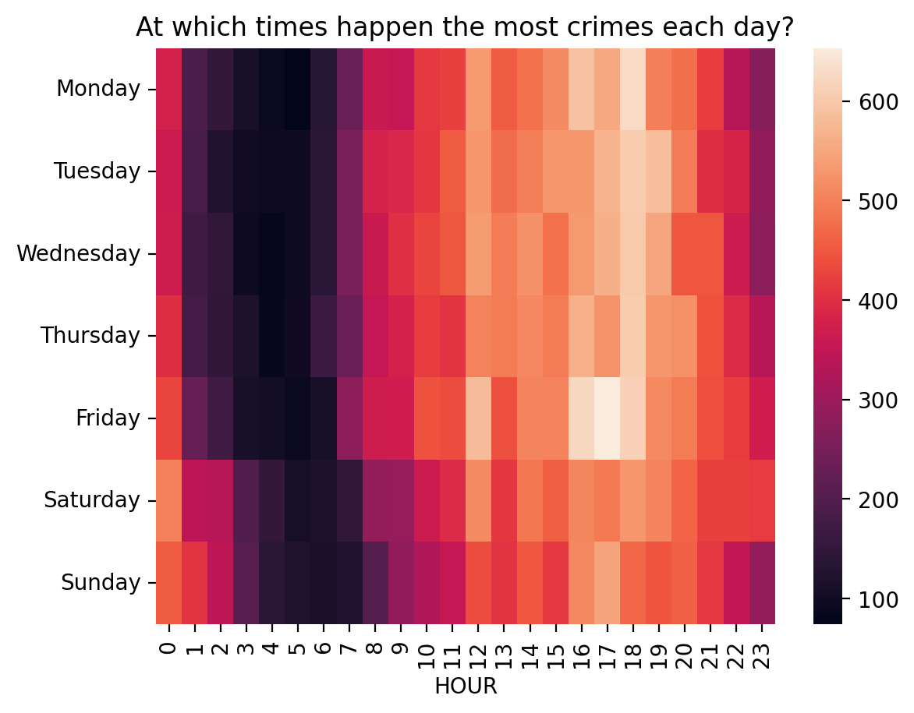
- Serious crimes happen mostly in the night hours from 1 to 8 am.
- On weekdays from 1 to 6 am and on weekends from 4 to 7 am.
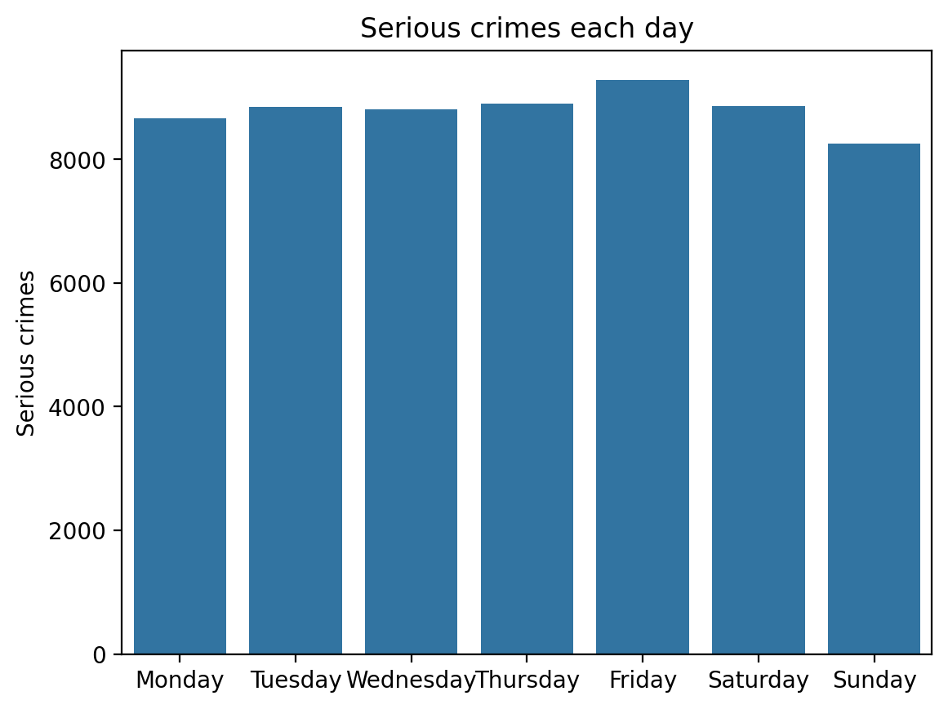
On fridays happen the most crimes and on sunday the less.
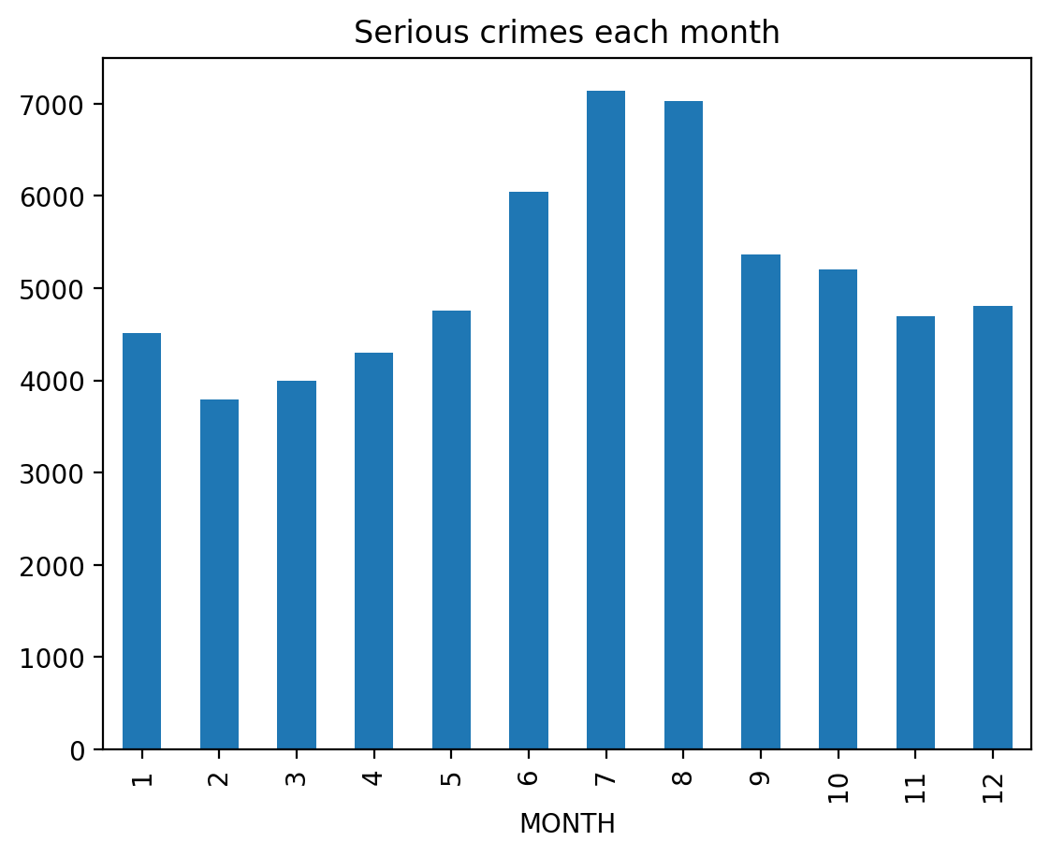
June, July and August are most crime heavy months.

Do crimes tend to occur at night or during the day?
More at night.

When are the most police officers needed?
Fridays in the summer months at night.

How has the number of shootings developed in recent years?
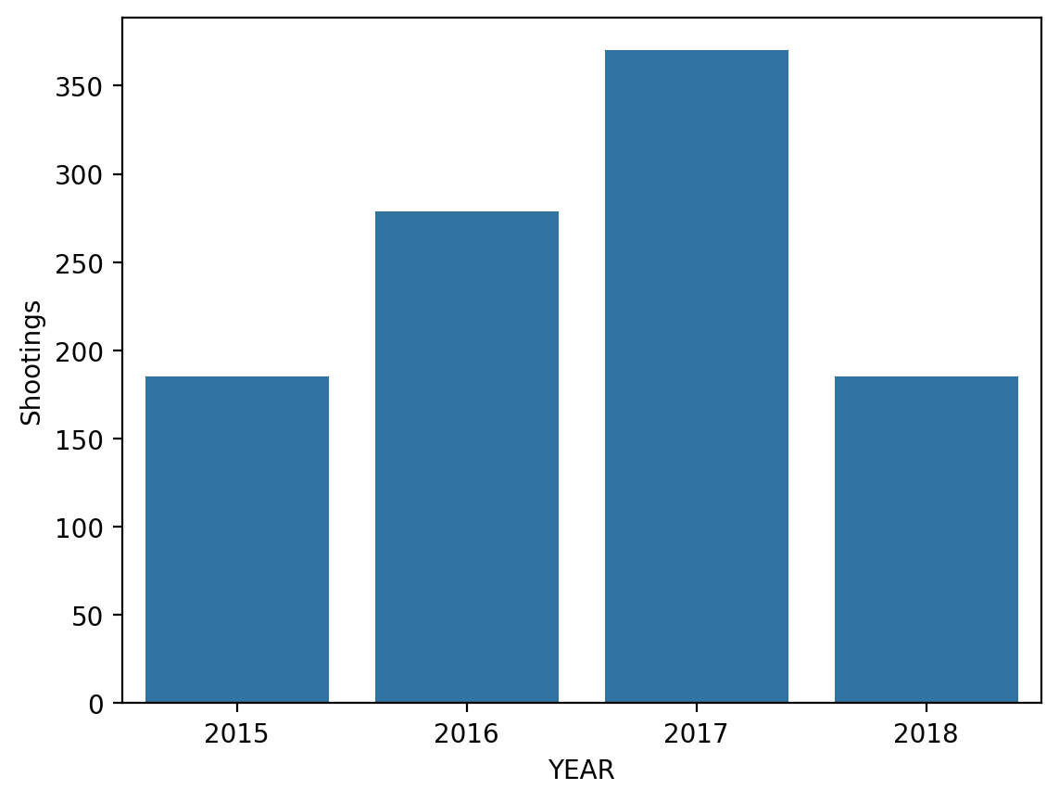
When we look at the absolute values it looks like shootings got more.
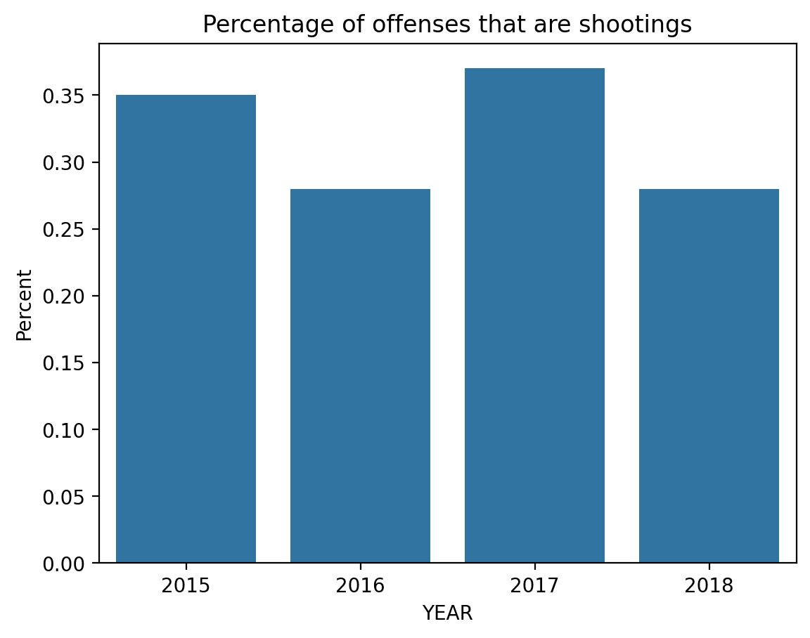
But relative to all offenses we can not see a clear picture.

In which district do most shootings take place?
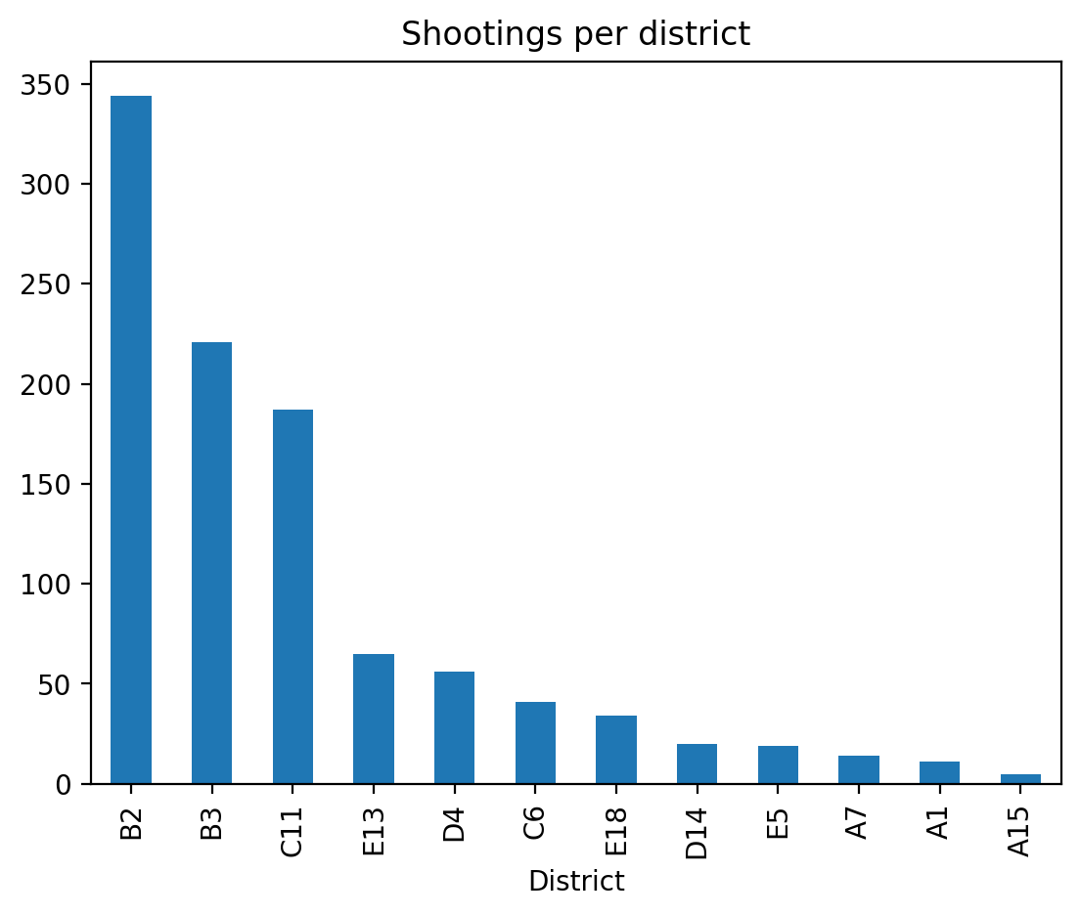

In which street do most shootings take place?
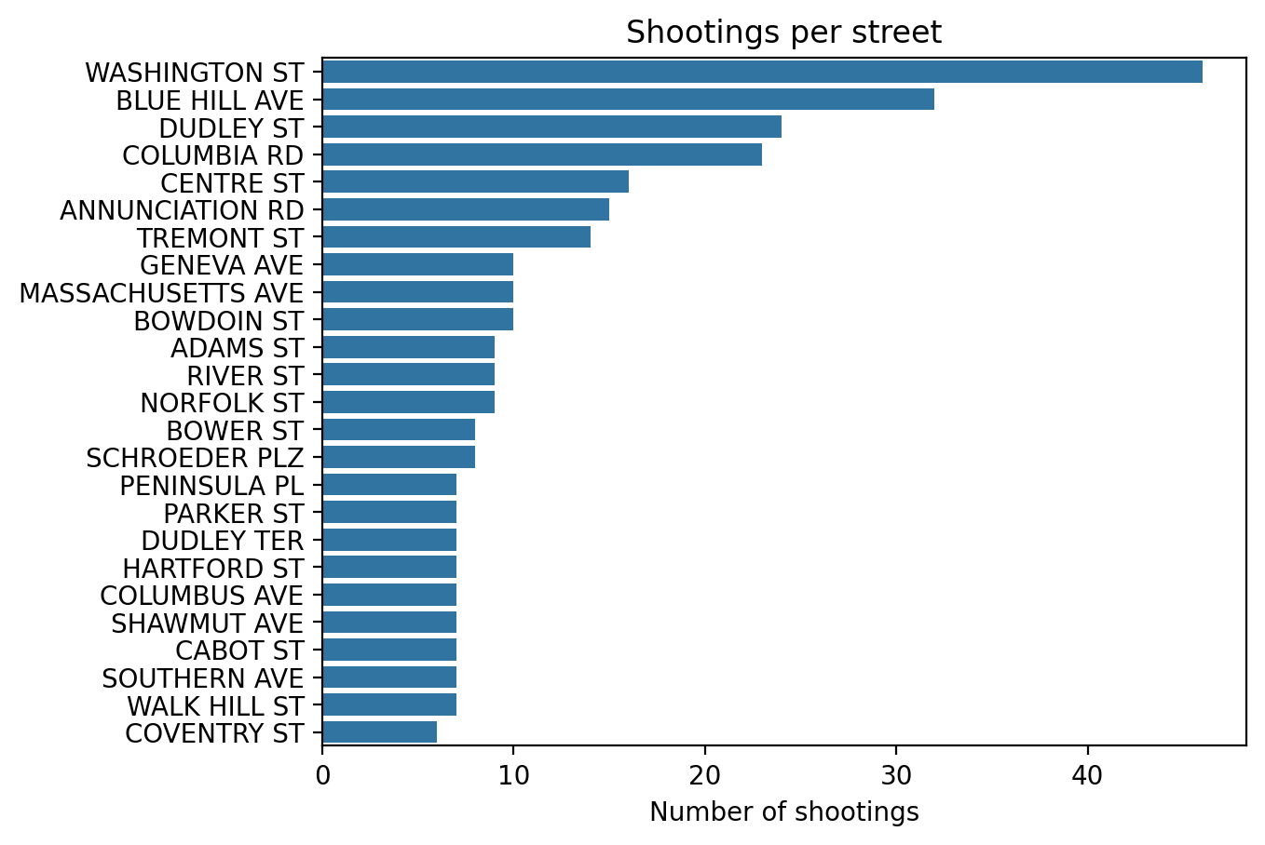

At what times do most shootings take place?
